payment_gateway | SBP
V1.0

Revision History
Version | Date | Description | Author
1.0 | 17/02/2026 | Initial Version | Mohammed Megahed

Reviewers
# | Name | Position | Date and Signature
1
2

Acceptance and Signoff
# | Name | Position | Date and Signature
1
2

Contents
1. Introduction 5
1.1. Project Summary 5
1.2. In-Scope 5
1.3. Out-Scope 5
1.4. Target Audience 5
1.5. Abbreviations 5
1.6. Assumptions, Dependencies and Risks 5
1.7. Impact Questionnaire 6
2. Requirements Compliancy Matrix 6
3. Solution Architecture 7
3.1. Solution Description 7
3.2. Non-Functional Requirements 8
3.3. Security Considerations 8
4. Card Payment Authorization Flow 9
4.1. Sequence Diagram 9
4.2. Flow Description 10
4.3. State Machine Diagram 12
4.4. APIs Contract Agreement 14
4.5. Error Handling 15
5. Refund Processing Flow 18
5.1. Sequence Diagram 18
5.2. Flow Description 19
5.3. State Machine Diagram 22
5.4. APIs Contract Agreement 23
5.5. Error Handling 25
6. Daily Settlement Process 27
6.1. Sequence Diagram 27
6.2. Flow Description 28
6.3. State Machine Diagram 31
6.4. APIs Contract Agreement 33
6.5. Error Handling 34
7. Appendix 38
7.1. Card Payment Authorization Flow Data Elements 38
7.2. Refund Processing Flow Data Elements 39
7.3. Daily Settlement Process Data Elements 40
7.4. Solution Architecture Reference Documents 42

1. Introduction

1.1. Project Summary
PayFlow is an enterprise payment gateway that enables merchants to securely accept online payments via major card networks and tokenized wallets, addressing the need for reliable and compliant digital payment processing. The platform supports 3D Secure 2.0 authentication, real-time fraud scoring, tokenization, and both full and partial refunds. This solution reduces payment risk and improves checkout conversion for merchants.

1.2. In-Scope
# | Item
1. | Card payment processing (VISA, Mastercard, AMEX, mada)
2. | 3D Secure 2.0 authentication
3. | Tokenized payments (Apple Pay, Google Pay)
4. | Full and partial refunds
5. | Real-time fraud scoring
6. | Daily merchant settlement
7. | Merchant portal and reporting

1.3. Out-Scope
# | Item
1. | Merchant acquiring and underwriting
2. | POS terminal management
3. | Recurring billing and subscriptions
4. | Multi-currency settlement

1.4. Target Audience
# | Stakeholders
1. | Enterprise Architects
2. | Partners and Vendors Technical Leaders
3. | Infrastructure Architects & Engineers
4. | InfoSec Architects & Engineers
5. | Technical Managers
6. | Delivery Leads and Project Managers
7. | Developers

1.5. Abbreviations
# | Abbreviations | Full form
1

1.6. Assumptions, Dependencies and Risks
# | Item | Type | Owner | Comment
1.
2.

2. Requirements Compliancy Matrix
ID. | Title | Description | Compliancy | Comments
FR-1 | PayFlow is an enterprise payment gateway enabling merchants to accept online pay | Merchants can accept online payments from customers using credit cards, debit cards, and digital wallets through the PayFlow payment gateway. This enables secure and efficient processing of electronic transactions to support online sales. | Compliant
FR-2 | The platform provides secure payment processing, fraud prevention, and automated | The platform enables users to make payments securely, protects transactions from fraud, and ensures payments are settled automatically and accurately. | Compliant
FR-3 | Support for 3D Secure 2.0 ensures strong customer authentication | The solution enables strong customer authentication by supporting 3D Secure 2.0, reducing fraud risk and helping meet regulatory requirements for secure online payments. | Compliant
FR-BR-001 | Merchant Onboarding | The business enables merchants to register and complete onboarding so they can offer products and services through the platform in compliance with applicable policies and regulations. | Compliant
FR-BR-002 | redentials | Users can securely access the API using unique credentials to protect sensitive data and ensure authorized use. | Compliant
FR-BR-003 | Card Authorization | Card transactions require authorization to confirm that the payment method is valid and has sufficient funds before completing a purchase. This ensures secure and reliable payment processing for customers and reduces the risk of fraudulent or declined transactions. | Compliant
FR-BR-004 | D Secure | Customers authenticate online card payments using 3D Secure to reduce fraud and increase transaction security. | Compliant
FR-BR-005 | Tokenization | Sensitive data is replaced with unique tokens to protect information and reduce the risk of unauthorized access or data breaches. | Compliant
FR-BR-006 | Fraud Scoring | The system assigns a fraud risk score to each transaction to help identify and prevent potential fraudulent activity. This enables the business to take appropriate action to reduce financial losses and protect customers. | Compliant
FR-BR-007 | Refunds | Customers can request and receive refunds for eligible products or services in accordance with company policies. This ensures fair treatment and builds trust with customers. | Compliant
FR-BR-008 | Settlement | The business ensures that all financial transactions are settled accurately and in a timely manner, meeting regulatory and contractual obligations. | Compliant
FR-BR-009 | Reconciliation | Ensure that all financial records are regularly reviewed and matched to verify accuracy and completeness. This process identifies discrepancies and supports reliable financial reporting. | Compliant
FR-BR-010 | Webhooks | The system enables real-time notifications to external parties when specific business events occur, allowing timely updates and improved coordination with partners and clients. | Compliant

3. Solution Architecture

3.1. Solution Description
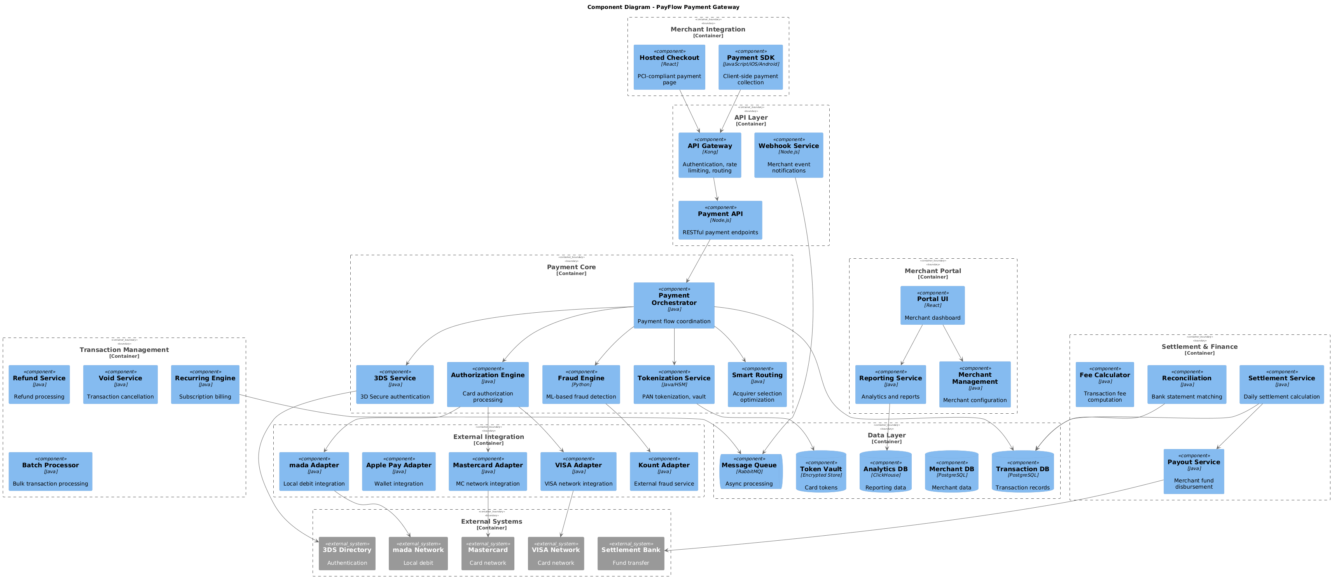

3.2. Non-Functional Requirements
# | Category | Requirement | Target/SLA
1 | Performance | API Response Time | < 2 seconds for 95th percentile
2 | Performance | Transaction Throughput | Support 100 TPS during peak hours
3 | Availability | System Uptime | 99.9% availability (excluding planned maintenance)
4 | Availability | Recovery Time Objective (RTO) | < 4 hours
5 | Availability | Recovery Point Objective (RPO) | < 1 hour
6 | Scalability | Horizontal Scaling | Support auto-scaling based on load
7 | Scalability | Concurrent Users | Support 1000 concurrent users
8 | Data Retention | Transaction Logs | Retain for 7 years as per regulatory requirements
9 | Data Retention | Audit Logs | Retain for 5 years
10 | Compliance | Regulatory | Comply with CMA and SAMA regulations
11 | Compliance | Data Protection | Comply with data privacy requirements

3.3. Security Considerations
# | Security Domain | Requirement | Implementation
1 | Authentication | User Authentication | OAuth 2.0 / JWT tokens with secure token storage
2 | Authentication | Service-to-Service Auth | Mutual TLS (mTLS) for internal service communication
3 | Authentication | Multi-Factor Authentication | MFA required for sensitive operations
4 | Authorization | Role-Based Access Control | RBAC implemented with principle of least privilege
5 | Authorization | API Authorization | Scope-based access control for API endpoints
6 | Data Protection | Data in Transit | TLS 1.2+ encryption for all network communication
7 | Data Protection | Data at Rest | AES-256 encryption for sensitive data storage
8 | Data Protection | PII/Sensitive Data | Data masking and tokenization for sensitive fields
9 | API Security | Input Validation | Server-side validation of all input parameters
10 | API Security | Rate Limiting | Rate limiting to prevent abuse and DDoS attacks
11 | API Security | CORS Policy | Strict CORS policy for web API endpoints
12 | Audit & Logging | Audit Trail | Log all security-relevant events with timestamps
13 | Audit & Logging | Log Protection | Immutable logs with tamper detection
14 | Vulnerability Management | Security Scanning | Regular SAST/DAST scanning in CI/CD pipeline
15 | Vulnerability Management | Dependency Scanning | Automated scanning for vulnerable dependencies

4. Card Payment Authorization Flow

4.1. Sequence Diagram
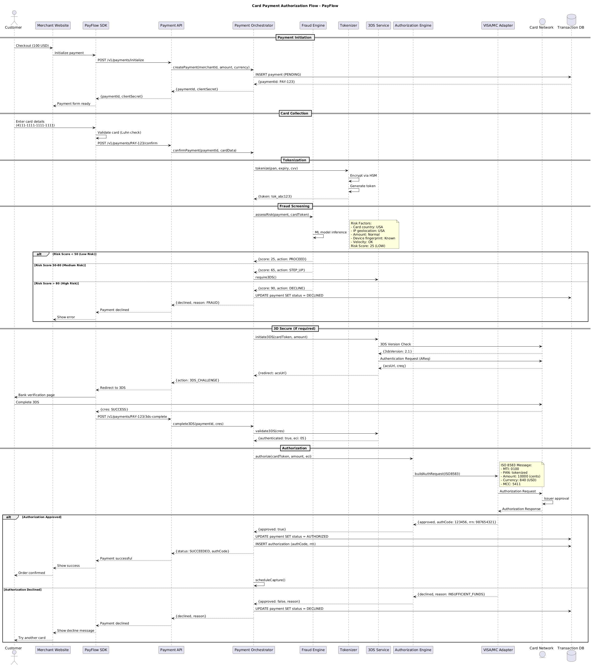

4.2. Flow Description
  - Overview
This flow describes the end-to-end card payment authorization process for the PayFlow platform, detailing the interactions between Customer, Merchant Website, PayFlow SDK, Payment API, Payment Orchestrator, Fraud Engine, Tokenizer, 3DS Service, Authorization Engine, VISA/MC Adapter, Card Network, and Transaction DB. The flow covers payment initiation, card data collection, tokenization, fraud screening with risk-based decisioning, conditional 3D Secure authentication, and final authorization with response handling.
  - Process Flow
Payment Initiation
The process begins when Customer initiates a checkout for 100 USD on Merchant Website. Merchant Website requests PayFlow SDK to initialize the payment. PayFlow SDK calls Payment API to initialize the payment session. Payment API forwards the payment creation request to Payment Orchestrator, providing merchant ID, amount, and currency. Payment Orchestrator inserts a new payment record with a PENDING status into Transaction DB. Transaction DB returns a generated payment ID (PAY-123) to Payment Orchestrator. Payment Orchestrator responds to Payment API with the payment ID and a client secret. Payment API passes these details to PayFlow SDK, which notifies Merchant Website that the payment form is ready.
Card Collection
Customer enters card details (4111-1111-1111-1111) into PayFlow SDK. PayFlow SDK internally validates the card using the Luhn algorithm. PayFlow SDK submits the card confirmation request to Payment API for the specific payment ID. Payment API forwards the confirmation and card data to Payment Orchestrator.
Tokenization
Payment Orchestrator sends the card data to Tokenizer for tokenization. Tokenizer internally encrypts the card data using an HSM. Tokenizer internally generates a token for the card. Tokenizer returns the generated token (tok_abc123) to Payment Orchestrator.
Fraud Screening
Payment Orchestrator requests Fraud Engine to assess the risk of the payment using payment details and the card token. Fraud Engine internally performs machine learning model inference to determine the risk score.
Note: Risk Factors:
- Card country: USA
- IP geolocation: USA
- Amount: Normal
- Device fingerprint: Known
- Velocity: OK
Risk Score: 25
If the risk score is less than 50, Fraud Engine responds to Payment Orchestrator with a score of 25 and an action to proceed.
If the risk score is between 50 and 80, Fraud Engine responds with a score of 65 and an action to step up authentication. In this case, Payment Orchestrator requests 3DS Service to require 3D Secure authentication.
If the risk score is greater than 80, Fraud Engine responds with a score of 90 and an action to decline the payment. Payment Orchestrator updates the payment status to DECLINED in Transaction DB, then returns a declined response with the reason "FRAUD" to Payment API. Payment API notifies PayFlow SDK that the payment is declined, and PayFlow SDK instructs Merchant Website to show an error to the customer.
3D Secure (if required)
If step-up authentication is required, Payment Orchestrator initiates 3D Secure authentication with 3DS Service, providing the card token and amount. 3DS Service checks the 3DS version with Card Network, which responds with version 2.1. 3DS Service sends an authentication request to Card Network, which returns the ACS URL and challenge request. 3DS Service provides Payment Orchestrator with the redirect URL for authentication. Payment Orchestrator instructs Payment API to initiate a 3DS challenge. Payment API tells PayFlow SDK to redirect the customer to 3DS. PayFlow SDK presents the bank verification page to Customer. Customer completes the 3DS challenge with Card Network. Card Network returns the challenge result (cres: SUCCESS) to PayFlow SDK. PayFlow SDK notifies Payment API that 3DS is complete. Payment API informs Payment Orchestrator of the completion and provides the challenge result. Payment Orchestrator requests 3DS Service to validate the 3DS result. 3DS Service confirms successful authentication and provides the ECI value (05) to Payment Orchestrator.
Authorization
Payment Orchestrator requests Authorization Engine to authorize the payment using the card token, amount, and ECI value. Authorization Engine instructs VISA/MC Adapter to build the authorization request in ISO 8583 format.
Note: ISO 8583 Message:
- MTI: 0100
- PAN: tokenized
- Amount: 10000
- Currency: 840
- MCC: 5411
VISA/MC Adapter sends the authorization request to Card Network. Card Network internally performs issuer approval. Card Network returns the authorization response to VISA/MC Adapter.
If the authorization is approved, VISA/MC Adapter returns approval details (authCode: 123456, rrn: 987654321) to Authorization Engine. Authorization Engine informs Payment Orchestrator that the authorization is successful. Payment Orchestrator updates the payment status to AUTHORIZED in Transaction DB and inserts the authorization record with the authorization code and retrieval reference number. Payment Orchestrator sends a success response with the authorization code to Payment API. Payment API notifies PayFlow SDK of the successful payment. PayFlow SDK informs Merchant Website to show the success message, and Merchant Website confirms the order to Customer. Payment Orchestrator internally schedules the capture of the authorized payment.
If the authorization is declined, VISA/MC Adapter returns a declined response with the reason "INSUFFICIENT_FUNDS" to Authorization Engine. Authorization Engine notifies Payment Orchestrator of the declined authorization. Payment Orchestrator updates the payment status to DECLINED in Transaction DB. Payment Orchestrator returns the decline reason to Payment API. Payment API notifies PayFlow SDK that the payment is declined. PayFlow SDK instructs Merchant Website to show the decline message, and Merchant Website prompts Customer to try another card.
  - Self-Interactions
PayFlow SDK internally validates the card using the Luhn check.
Tokenizer internally encrypts the card data via HSM.
Tokenizer internally generates a token.
Fraud Engine internally performs machine learning model inference.
Card Network internally performs issuer approval.
Payment Orchestrator internally schedules the capture of the authorized payment.

4.3. State Machine Diagram
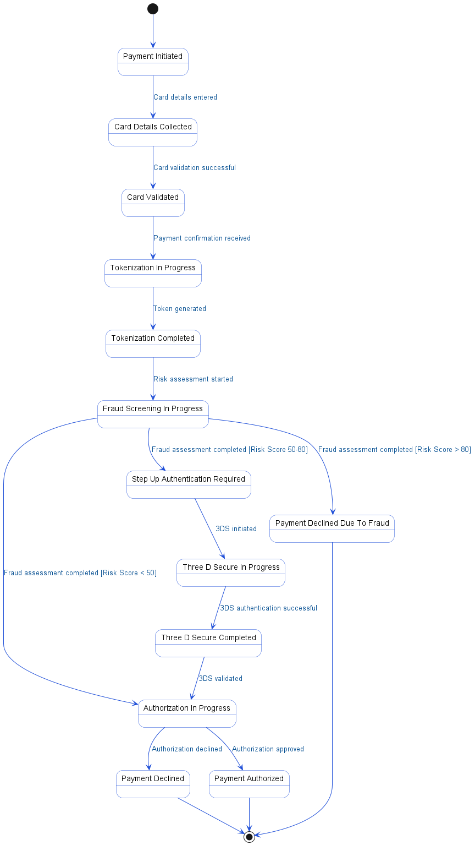

4.4. APIs Contract Agreement
# | Source | Destination | API | Protocol | Request Parameters | Response Parameters
1 | Merchant Website | PayFlow SDK | Initialize payment | REST |  | Payment form ready
2 | PayFlow SDK | Payment API | POST /v1/payments/initialize | REST |  | {paymentId, clientSecret}
3 | Payment API | Payment Orchestrator | createPayment | REST | merchantId, amount, currency | {paymentId, clientSecret}
4 | Payment Orchestrator | Transaction DB | INSERT payment | JDBC | PENDING | {paymentId: PAY-123}
5 | PayFlow SDK | Payment API | POST /v1/payments/PAY-123/confirm | REST |  | Payment declined
6 | Payment API | Payment Orchestrator | confirmPayment | REST | paymentId, cardData | {declined, reason: FRAUD}
7 | Payment Orchestrator | Tokenizer | tokenize | REST | pan, expiry, cvv | {token: tok_abc123}
8 | Payment Orchestrator | Fraud Engine | assessRisk | REST | payment, cardToken | {score: 25, action: PROCEED}
9 | Payment Orchestrator | 3DS Service | require3DS | REST |  | {redirect: acsUrl}
10 | Payment Orchestrator | Transaction DB | UPDATE payment SET status = DECLINED | JDBC
11 | Payment Orchestrator | 3DS Service | initiate3DS | REST | cardToken, amount | {authenticated: true, eci: 05}
12 | 3DS Service | Card Network | 3DS Version Check | REST |  | {3dsVersion: 2.1}
13 | 3DS Service | Card Network | Authentication Request | REST | AReq | {acsUrl, creq}
14 | PayFlow SDK | Customer | Bank verification page | REST
15 | PayFlow SDK | Payment API | POST /v1/payments/PAY-123/3ds-complete | REST |  | Payment successful
16 | Payment API | Payment Orchestrator | complete3DS | REST | paymentId, cres | {status: SUCCEEDED, authCode}
17 | Payment Orchestrator | 3DS Service | validate3DS | REST | cres
18 | Payment Orchestrator | Authorization Engine | authorize | REST | cardToken, amount, eci | {approved: true}
19 | Authorization Engine | VISA/MC Adapter | buildAuthRequest | REST | ISO8583 | {approved, authCode: 123456, rrn: 987654321}
20 | VISA/MC Adapter | Card Network | Authorization Request | REST |  | Authorization Response
21 | Payment Orchestrator | Transaction DB | UPDATE payment SET status = AUTHORIZED | JDBC
22 | Payment Orchestrator | Transaction DB | INSERT authorization | JDBC | authCode, rrn
23 | Payment Orchestrator | Transaction DB | UPDATE payment SET status = DECLINED | JDBC
[*] Indicates that the data element is optional

4.5. Error Handling
# | Source | Destination | Scenario | Handling
1 | PayFlow SDK | Payment API | POST /v1/payments/initialize  Timeout waiting for Payment API response | Retry up to 3 times with exponential backoff; Log error with correlation ID for traceability; Return error code to upstream caller
2 | PayFlow SDK | Payment API | POST /v1/payments/initialize  Payment API unavailable | Retry up to 3 times with exponential backoff; Log error with correlation ID for traceability; Return error code to upstream caller
3 | Payment API | Payment Orchestrator | createPayment  Timeout waiting for Payment Orchestrator response | Retry up to 3 times with exponential backoff; Log error with correlation ID for traceability; Return error code to upstream caller
4 | Payment API | Payment Orchestrator | createPayment  Payment Orchestrator unavailable | Retry up to 3 times with exponential backoff; Log error with correlation ID for traceability; Return error code to upstream caller
5 | PayFlow SDK | Payment API | POST /v1/payments/PAY-123/confirm  Timeout waiting for Payment API response | Retry up to 3 times with exponential backoff; Log error with correlation ID for traceability; Return error code to upstream caller
6 | PayFlow SDK | Payment API | POST /v1/payments/PAY-123/confirm  Payment API unavailable | Retry up to 3 times with exponential backoff; Log error with correlation ID for traceability; Return error code to upstream caller
7 | Payment API | Payment Orchestrator | confirmPayment  Timeout waiting for Payment Orchestrator response | Retry up to 3 times with exponential backoff; Log error with correlation ID for traceability; Return error code to upstream caller
8 | Payment API | Payment Orchestrator | confirmPayment  Payment Orchestrator unavailable | Retry up to 3 times with exponential backoff; Log error with correlation ID for traceability; Return error code to upstream caller
9 | Payment Orchestrator | Tokenizer | tokenize  Timeout waiting for Tokenizer response | Retry up to 3 times with exponential backoff; Log error with correlation ID for traceability; Return error code to upstream caller
10 | Payment Orchestrator | Tokenizer | tokenize  Tokenizer unavailable | Retry up to 3 times with exponential backoff; Log error with correlation ID for traceability; Return error code to upstream caller
11 | Payment Orchestrator | Fraud Engine | assessRisk  Timeout waiting for Fraud Engine response | Retry up to 3 times with exponential backoff; Log error with correlation ID for traceability; Activate circuit breaker, use fallback response
12 | Payment Orchestrator | Fraud Engine | assessRisk  Fraud Engine unavailable | Retry up to 3 times with exponential backoff; Log error with correlation ID for traceability; Activate circuit breaker, use fallback response
13 | Payment Orchestrator | 3DS Service | require3DS  Timeout waiting for 3DS Service response | Retry up to 3 times with exponential backoff; Log error with correlation ID for traceability; Return error code to upstream caller
14 | Payment Orchestrator | 3DS Service | require3DS  3DS Service unavailable | Retry up to 3 times with exponential backoff; Log error with correlation ID for traceability; Return error code to upstream caller
15 | Payment Orchestrator | 3DS Service | initiate3DS  Timeout waiting for 3DS Service response | Retry up to 3 times with exponential backoff; Log error with correlation ID for traceability; Return error code to upstream caller
16 | Payment Orchestrator | 3DS Service | initiate3DS  3DS Service unavailable | Retry up to 3 times with exponential backoff; Log error with correlation ID for traceability; Return error code to upstream caller
17 | 3DS Service | Card Network | 3DS Version Check  Timeout waiting for Card Network response | Retry up to 3 times with exponential backoff; Log error with correlation ID for traceability; Activate circuit breaker, use fallback response
18 | 3DS Service | Card Network | 3DS Version Check  Card Network unavailable | Retry up to 3 times with exponential backoff; Log error with correlation ID for traceability; Activate circuit breaker, use fallback response
19 | 3DS Service | Card Network | Authentication Request  Timeout waiting for Card Network response | Retry up to 3 times with exponential backoff; Log error with correlation ID for traceability; Activate circuit breaker, use fallback response
20 | 3DS Service | Card Network | Authentication Request  Card Network unavailable | Retry up to 3 times with exponential backoff; Log error with correlation ID for traceability; Activate circuit breaker, use fallback response
21 | Payment API | Payment Orchestrator | complete3DS  Timeout waiting for Payment Orchestrator response | Retry up to 3 times with exponential backoff; Log error with correlation ID for traceability; Return error code to upstream caller
22 | Payment API | Payment Orchestrator | complete3DS  Payment Orchestrator unavailable | Retry up to 3 times with exponential backoff; Log error with correlation ID for traceability; Return error code to upstream caller
23 | Payment Orchestrator | 3DS Service | validate3DS  Timeout waiting for 3DS Service response | Retry up to 3 times with exponential backoff; Log error with correlation ID for traceability; Return error code to upstream caller
24 | Payment Orchestrator | 3DS Service | validate3DS  3DS Service unavailable | Retry up to 3 times with exponential backoff; Log error with correlation ID for traceability; Return error code to upstream caller
25 | Payment Orchestrator | Authorization Engine | authorize  Timeout waiting for Authorization Engine response | Ensure idempotency to avoid duplicates on retry; Retry up to 3 times with exponential backoff; Log error with correlation ID for traceability; Return error code to upstream caller
26 | Payment Orchestrator | Authorization Engine | authorize  Authorization Engine unavailable | Ensure idempotency to avoid duplicates on retry; Retry up to 3 times with exponential backoff; Log error with correlation ID for traceability; Return error code to upstream caller
27 | Authorization Engine | VISA/MC Adapter | buildAuthRequest  Timeout waiting for VISA/MC Adapter response | Ensure idempotency to avoid duplicates on retry; Retry up to 3 times with exponential backoff; Log error with correlation ID for traceability; Return error code to upstream caller
28 | Authorization Engine | VISA/MC Adapter | buildAuthRequest  VISA/MC Adapter unavailable | Ensure idempotency to avoid duplicates on retry; Retry up to 3 times with exponential backoff; Log error with correlation ID for traceability; Return error code to upstream caller
29 | VISA/MC Adapter | Card Network | Authorization Request  Timeout waiting for Card Network response | Ensure idempotency to avoid duplicates on retry; Retry up to 3 times with exponential backoff; Log error with correlation ID for traceability; Activate circuit breaker, use fallback response
30 | VISA/MC Adapter | Card Network | Authorization Request  Card Network unavailable | Ensure idempotency to avoid duplicates on retry; Retry up to 3 times with exponential backoff; Log error with correlation ID for traceability; Activate circuit breaker, use fallback response

5. Refund Processing Flow

5.1. Sequence Diagram
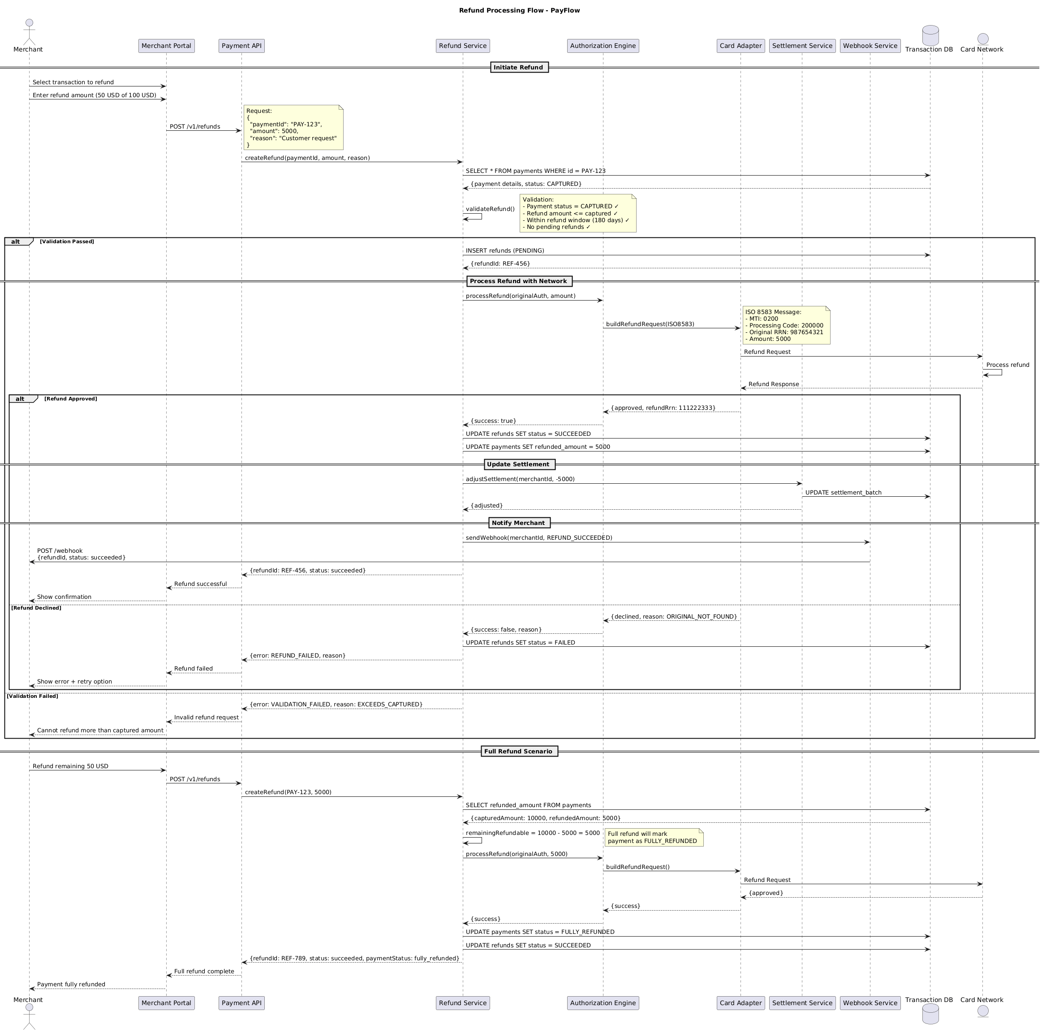

5.2. Flow Description
  - Overview
This flow describes the end-to-end refund processing for card payments in the PayFlow system. It covers the interactions between Merchant, Merchant Portal, Payment API, Refund Service, Authorization Engine, Card Adapter, Settlement Service, Webhook Service, Transaction DB, and Card Network. The flow addresses both partial and full refund scenarios, including validation, network processing, settlement adjustment, merchant notification, and error handling. All control flows, internal operations, and technical notes are reflected as represented in the diagram.
  - Process Flow
Initiate Refund
The refund process begins when Merchant selects a transaction to refund in Merchant Portal. Merchant then enters the refund amount, specifying a partial refund of 50 USD from a 100 USD payment.
Merchant Portal sends a POST request to Payment API at the endpoint /v1/refunds.
Note: Request:
{
"paymentId": "PAY-123",
"amount": 5000,
"reason": "Customer request"
}
Payment API forwards the refund creation request to Refund Service by invoking createRefund with the payment ID, amount, and reason.
Refund Service queries Transaction DB to retrieve payment details for the given payment ID. Transaction DB responds with the payment details, indicating the payment status is CAPTURED.
Refund Service internally performs validateRefund().
Note: Validation:
- Payment status = CAPTURED ✓
- Refund amount <= captured ✓
- Within refund window (180 days) ✓
- No pending refunds ✓
If all validation checks pass, Refund Service inserts a new refund record with status PENDING into Transaction DB. Transaction DB returns the generated refund ID.
Process Refund with Network
Refund Service requests Authorization Engine to process the refund, providing the original authorization and refund amount.
Authorization Engine instructs Card Adapter to build a refund request in ISO 8583 format.
Note: ISO 8583 Message:
- MTI: 0200
- Processing Code: 200000
- Original RRN: 987654321
- Amount: 5000
Card Adapter sends the refund request to Card Network.
Card Network internally processes the refund.
Card Adapter receives the refund response from Card Network.
If the refund is approved, Card Adapter returns an approved response with the refund RRN to Authorization Engine, which then notifies Refund Service of the success.
Refund Service updates the refund status to SUCCEEDED in Transaction DB. It also updates the payment record in Transaction DB to reflect the refunded amount of 5000.
Update Settlement
Refund Service instructs Settlement Service to adjust the merchant's settlement by subtracting 5000. Settlement Service updates the settlement batch in Transaction DB and confirms the adjustment to Refund Service.
Notify Merchant
Refund Service calls Webhook Service to send a webhook notification to the merchant, indicating that the refund succeeded.
Webhook Service sends a POST request to Merchant with the refund ID and succeeded status.
Refund Service returns a success response to Payment API with the refund ID and status.
Payment API notifies Merchant Portal that the refund was successful.
Merchant Portal presents a confirmation to Merchant.
If the refund is declined by Card Network, Card Adapter returns a declined response with the reason to Authorization Engine, which then informs Refund Service of the failure.
Refund Service updates the refund status to FAILED in Transaction DB. It responds to Payment API with an error and reason. Payment API notifies Merchant Portal of the refund failure. Merchant Portal displays an error and retry option to Merchant.
If validation fails at the initial stage, Refund Service returns a validation error to Payment API, specifying the reason (such as exceeding the captured amount). Payment API notifies Merchant Portal of the invalid refund request. Merchant Portal informs Merchant that the refund cannot exceed the captured amount.
Full Refund Scenario
To complete a full refund, Merchant initiates a request to refund the remaining 50 USD through Merchant Portal. Merchant Portal sends the refund request to Payment API, which forwards it to Refund Service.
Refund Service queries Transaction DB for the captured and already refunded amounts. Transaction DB responds with a captured amount of 10000 and refunded amount of 5000.
Refund Service internally performs remainingRefundable = 10000 - 5000 = 5000.
Note: Full refund will mark
payment as FULLY_REFUNDED
Refund Service requests Authorization Engine to process the refund for the remaining amount. Authorization Engine instructs Card Adapter to build the refund request, which is sent to Card Network.
Card Adapter receives an approved response from Card Network and notifies Authorization Engine of the success. Authorization Engine confirms the success to Refund Service.
Refund Service updates the payment status to FULLY_REFUNDED in Transaction DB. It also updates the refund status to SUCCEEDED.
Refund Service responds to Payment API with the refund ID, succeeded status, and payment status as fully_refunded. Payment API informs Merchant Portal that the full refund is complete. Merchant Portal notifies Merchant that the payment is fully refunded.
  - Authentication & Validation
Refund Service is responsible for validating refund requests. It checks that the payment status is CAPTURED, the refund amount does not exceed the captured amount, the request is within the 180-day refund window, and there are no pending refunds for the payment. These validation steps are performed internally by Refund Service before proceeding with network processing or database updates.
  - Internal Operations
Refund Service internally performs validateRefund() to enforce all refund validation rules.
Card Network internally processes the refund when it receives the refund request.
Refund Service internally performs remainingRefundable = 10000 - 5000 = 5000 to calculate the remaining refundable amount during the full refund scenario.

5.3. State Machine Diagram
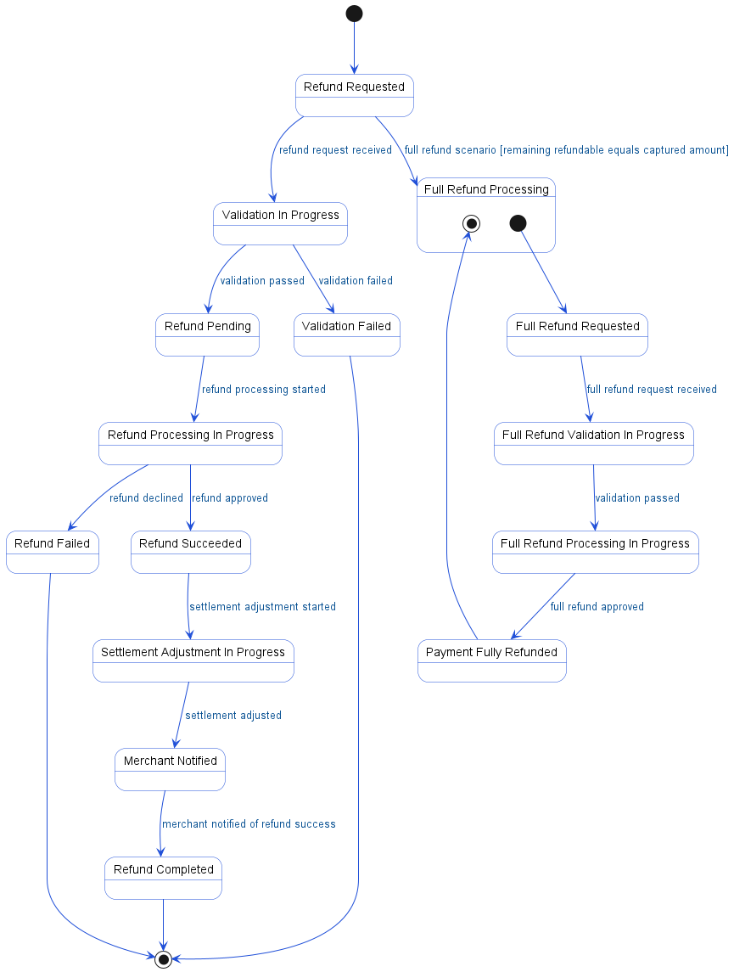

5.4. APIs Contract Agreement
# | Source | Destination | API | Protocol | Request Parameters | Response Parameters
1 | Merchant Portal | Payment API | POST /v1/refunds | REST |  | Refund successful
2 | Payment API | Refund Service | createRefund | REST | paymentId, amount, reason | {refundId: REF-456, status: succeeded}
3 | Refund Service | Transaction DB | SELECT * FROM payments WHERE id = PAY-123 | JDBC |  | {payment details, status: CAPTURED}
4 | Refund Service | Transaction DB | INSERT refunds | JDBC | PENDING | {refundId: REF-456}
5 | Refund Service | Authorization Engine | processRefund | REST | originalAuth, amount | {success: true}
6 | Authorization Engine | Card Adapter | buildRefundRequest | REST | ISO8583 | {approved, refundRrn: 111222333}
7 | Card Adapter | Card Network | Refund Request | REST |  | Refund Response
8 | Refund Service | Transaction DB | UPDATE refunds SET status = SUCCEEDED | JDBC |  | {capturedAmount: 10000, refundedAmount: 5000}
9 | Refund Service | Transaction DB | UPDATE payments SET refunded_amount = 5000 | JDBC
10 | Refund Service | Settlement Service | adjustSettlement | REST | merchantId, -5000 | {adjusted}
11 | Settlement Service | Transaction DB | UPDATE settlement_batch | JDBC
12 | Refund Service | Webhook Service | sendWebhook | REST | merchantId, REFUND_SUCCEEDED
13 | Webhook Service | Merchant | POST /webhook\n{refundId, status: succeeded} | REST
14 | Refund Service | Transaction DB | UPDATE refunds SET status = FAILED | JDBC
15 | Merchant Portal | Payment API | POST /v1/refunds | REST |  | Full refund complete
16 | Payment API | Refund Service | createRefund | REST | PAY-123, 5000 | {refundId: REF-789, status: succeeded, paymentStatus: fully_refunded}
17 | Refund Service | Transaction DB | SELECT refunded_amount FROM payments | JDBC
18 | Refund Service | Authorization Engine | processRefund | REST | originalAuth, 5000 | {success}
19 | Authorization Engine | Card Adapter | buildRefundRequest | REST |  | {success}
20 | Card Adapter | Card Network | Refund Request | REST |  | {approved}
21 | Refund Service | Transaction DB | UPDATE payments SET status = FULLY_REFUNDED | JDBC
22 | Refund Service | Transaction DB | UPDATE refunds SET status = SUCCEEDED | JDBC
[*] Indicates that the data element is optional

5.5. Error Handling
# | Source | Destination | Scenario | Handling
1 | Payment API | Refund Service | createRefund  Timeout waiting for refund creation response from Refund Service | Retry up to 3 times with exponential backoff; Log error with correlation ID for traceability; Return error code to upstream caller
2 | Payment API | Refund Service | createRefund  Refund Service unavailable during refund creation request | Retry up to 3 times with exponential backoff; Log error with correlation ID for traceability; Activate circuit breaker, use fallback response
3 | Refund Service | Authorization Engine | processRefund  Timeout waiting for Authorization Engine to process refund | Ensure idempotency to avoid duplicates on retry; Retry up to 3 times with exponential backoff; Log error with correlation ID for traceability; Return error code to upstream caller
4 | Refund Service | Authorization Engine | processRefund  Authorization Engine unavailable during refund processing | Ensure idempotency to avoid duplicates on retry; Retry up to 3 times with exponential backoff; Log error with correlation ID for traceability; Activate circuit breaker, use fallback response
5 | Refund Service | Authorization Engine | processRefund  Duplicate refund request detected by Authorization Engine | Ensure idempotency to avoid duplicates on retry; Log error with correlation ID for traceability; Return error code to upstream caller
6 | Refund Service | Authorization Engine | processRefund  Validation failure in Authorization Engine (e.g., original authorization not found) | Ensure idempotency to avoid duplicates on retry; Log error with correlation ID for traceability; Return error code to upstream caller
7 | Authorization Engine | Card Adapter | buildRefundRequest  Timeout waiting for Card Adapter to build refund request | Retry up to 3 times with exponential backoff; Log error with correlation ID for traceability; Return error code to upstream caller
8 | Authorization Engine | Card Adapter | buildRefundRequest  Card Adapter unavailable during refund request build | Retry up to 3 times with exponential backoff; Log error with correlation ID for traceability; Activate circuit breaker, use fallback response
9 | Card Adapter | Card Network | Refund Request  Timeout waiting for Card Network to respond to refund request | Retry up to 3 times with exponential backoff; Log error with correlation ID for traceability; Return error code to upstream caller
10 | Card Adapter | Card Network | Refund Request  Card Network unavailable during refund request | Retry up to 3 times with exponential backoff; Log error with correlation ID for traceability; Activate circuit breaker, use fallback response
11 | Refund Service | Settlement Service | adjustSettlement  Timeout waiting for Settlement Service to adjust settlement | Ensure idempotency to avoid duplicates on retry; Retry up to 3 times with exponential backoff; Log error with correlation ID for traceability; Queue request for asynchronous retry
12 | Refund Service | Settlement Service | adjustSettlement  Settlement Service unavailable during settlement adjustment | Ensure idempotency to avoid duplicates on retry; Retry up to 3 times with exponential backoff; Log error with correlation ID for traceability; Notify operations team via alert if repeated
13 | Refund Service | Settlement Service | adjustSettlement  Duplicate settlement adjustment request detected | Ensure idempotency to avoid duplicates on retry; Log error with correlation ID for traceability; Return error code to upstream caller
14 | Refund Service | Settlement Service | adjustSettlement  Validation failure in Settlement Service (e.g., invalid merchantId) | Ensure idempotency to avoid duplicates on retry; Log error with correlation ID for traceability; Return error code to upstream caller
15 | Refund Service | Webhook Service | sendWebhook  Timeout waiting for Webhook Service to acknowledge webhook delivery | Retry up to 3 times with exponential backoff; Log error with correlation ID for traceability; Queue request for asynchronous retry
16 | Refund Service | Webhook Service | sendWebhook  Webhook Service unavailable during webhook notification | Retry up to 3 times with exponential backoff; Log error with correlation ID for traceability; Notify operations team via alert if repeated
17 | Refund Service | Webhook Service | sendWebhook  Duplicate webhook notification request detected | Log error with correlation ID for traceability; Return error code to upstream caller
18 | Refund Service | Webhook Service | sendWebhook  Validation failure in Webhook Service (e.g., invalid merchantId) | Log error with correlation ID for traceability; Return error code to upstream caller

6. Daily Settlement Process

6.1. Sequence Diagram
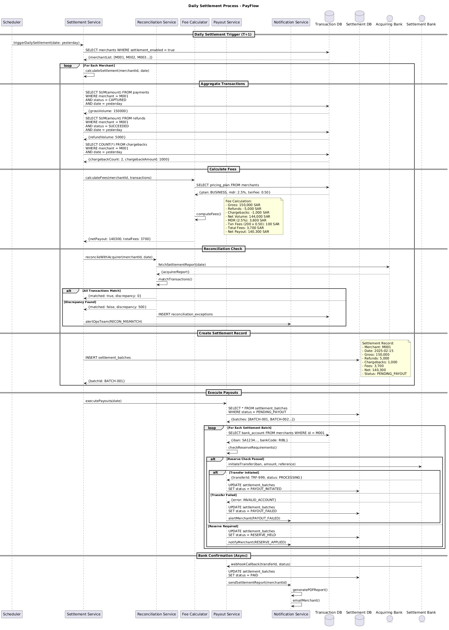

6.2. Flow Description
  - Overview
This flow details the daily settlement process for PayFlow, orchestrating the end-to-end settlement lifecycle for merchants. The process is initiated by Scheduler and involves several core systems: Settlement Service, Transaction DB, Fee Calculator, Reconciliation Service, Acquiring Bank, Settlement DB, Payout Service, Settlement Bank, and Notification Service. The flow covers merchant transaction aggregation, fee computation, reconciliation with the acquiring bank, settlement batch creation, payout execution, and post-settlement notifications. Each participant is responsible for a distinct phase, with explicit handling of conditional and alternative scenarios, as well as internal processing steps.
  - Process Flow
Daily Settlement Trigger
Scheduler triggers the daily settlement process for the previous day by invoking Settlement Service with the relevant date. Settlement Service queries Transaction DB to retrieve all merchants with settlement enabled. Transaction DB responds with a list of eligible merchants.
Settlement Calculation Loop
For each merchant in the list, Settlement Service internally performs calculateSettlement for the given merchant and date.
SUB### Aggregate Transactions
Settlement Service requests the total captured payment volume for the merchant and date from Transaction DB. Transaction DB returns the gross transaction volume. Settlement Service then requests the total succeeded refund volume for the merchant and date, receiving the refund volume in response. Next, Settlement Service queries Transaction DB for the count and total amount of chargebacks for the merchant and date, and receives the chargeback details.
SUB### Calculate Fees
Settlement Service requests fee calculation from Fee Calculator, providing the merchant and transaction data. Fee Calculator queries Transaction DB for the merchant’s pricing plan and receives the plan details, including MDR and transaction fee rates. Fee Calculator internally performs computeFees().
Note: Fee Calculation:
- Gross: 150,000 SAR
- Refunds: -5,000 SAR
- Chargebacks: -1,000 SAR
- Net Volume: 144,000 SAR
- MDR (2.5%): 3,600 SAR
- Txn Fees (200 x 0.50): 100 SAR
- Total Fees: 3,700 SAR
- Net Payout: 140,300 SAR
Fee Calculator returns the net payout and total fees to Settlement Service.
SUB### Reconciliation Check
Settlement Service requests reconciliation from Reconciliation Service for the merchant and date. Reconciliation Service fetches the settlement report from Acquiring Bank, which responds with the acquirer’s report. Reconciliation Service internally performs matchTransactions().
If all transactions match, Reconciliation Service returns a matched status with zero discrepancy to Settlement Service. Otherwise, if a discrepancy is found, Reconciliation Service returns a non-matched status and the discrepancy amount. Reconciliation Service then inserts a reconciliation exception into Transaction DB, and Settlement Service notifies Notification Service to alert the operations team of the reconciliation mismatch.
SUB### Create Settlement Record
Settlement Service inserts a new settlement batch record into Settlement DB.
Note: Settlement Record:
- Merchant: M001
- Date: 2025-02-15
- Gross: 150,000
- Refunds: 5,000
- Chargebacks: 1,000
- Fees: 3,700
- Net: 140,300
- Status: PENDING_PAYOUT
Settlement DB responds with the batch ID for the created settlement batch.
Execute Payouts
Settlement Service instructs Payout Service to execute payouts for the specified date. Payout Service queries Settlement DB for all settlement batches with status PENDING_PAYOUT, receiving the list of batches.
For each settlement batch, Payout Service requests the merchant’s bank account details from Transaction DB, which responds with the IBAN and bank code. Payout Service internally performs checkReserveRequirements().
If the reserve check passes, Payout Service initiates a transfer with Settlement Bank using the merchant’s account details and payout amount.
If the transfer is initiated, Settlement Bank responds with a transfer ID and processing status. Payout Service updates the settlement batch status in Settlement DB to PAYOUT_INITIATED.
If the transfer fails, Settlement Bank responds with an error. Payout Service updates the settlement batch status in Settlement DB to PAYOUT_FAILED and notifies Notification Service to alert the merchant of the payout failure.
If the reserve check requires holding funds, Payout Service updates the settlement batch status in Settlement DB to RESERVE_HELD and notifies Notification Service to inform the merchant that a reserve has been applied.
Bank Confirmation (Async)
Upon transfer completion, Settlement Bank sends an asynchronous webhook callback to Payout Service with the transfer ID and status. Payout Service updates the settlement batch status in Settlement DB to PAID. Payout Service then instructs Notification Service to send the settlement report to the merchant. Notification Service internally generates the PDF report. Notification Service internally emails the merchant.
  - Authentication & Validation
All internal operations, validations, and status updates are handled by the respective services as described in the flow. Each self-interaction is explicitly executed to ensure data integrity and process consistency.
  - Self-Interactions
Settlement Service internally performs calculateSettlement(merchantId, date).
Fee Calculator internally performs computeFees().
Reconciliation Service internally performs matchTransactions().
Payout Service internally performs checkReserveRequirements().
Notification Service internally generates the PDF report.
Notification Service internally emails the merchant.

6.3. State Machine Diagram
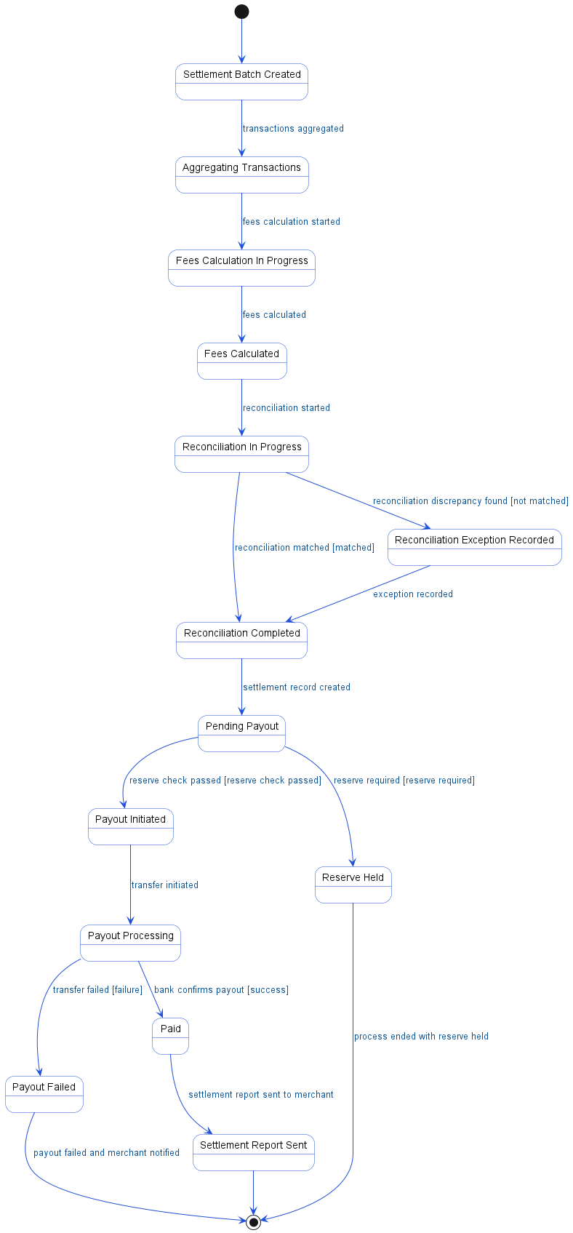

6.4. APIs Contract Agreement
# | Source | Destination | API | Protocol | Request Parameters | Response Parameters
1 | Scheduler | Settlement Service | triggerDailySettlement | REST | date: yesterday
2 | Settlement Service | Transaction DB | SELECT merchants WHERE settlement_enabled = true | JDBC |  | {merchantList: [M001, M002, M003...]}
3 | Settlement Service | Transaction DB | SELECT SUM | JDBC | amount | {grossVolume: 150000}
4 | Settlement Service | Transaction DB | SELECT SUM | JDBC | amount | {refundVolume: 5000}
5 | Settlement Service | Transaction DB | SELECT COUNT | JDBC | * | {chargebackCount: 2, chargebackAmount: 1000}
6 | Settlement Service | Fee Calculator | calculateFees | REST | merchantId, transactions | {netPayout: 140300, totalFees: 3700}
7 | Fee Calculator | Transaction DB | SELECT pricing_plan FROM merchants | JDBC |  | {plan: BUSINESS, mdr: 2.5%, txnFee: 0.50}
8 | Settlement Service | Reconciliation Service | reconcileWithAcquirer | REST | merchantId, date | {matched: true, discrepancy: 0}
9 | Reconciliation Service | Acquiring Bank | fetchSettlementReport | REST | date | {acquirerReport}
10 | Reconciliation Service | Transaction DB | INSERT reconciliation_exceptions | JDBC
11 | Settlement Service | Notification Service | alertOpsTeam | REST | RECON_MISMATCH
12 | Settlement Service | Settlement DB | INSERT settlement_batches | JDBC |  | {batchId: BATCH-001}
13 | Settlement Service | Payout Service | executePayouts | REST | date
14 | Payout Service | Settlement DB | SELECT * FROM settlement_batches\nWHERE status = PENDING_PAYOUT | JDBC |  | {batches: [BATCH-001, BATCH-002...]}
15 | Payout Service | Transaction DB | SELECT bank_account FROM merchants WHERE id = M001 | JDBC |  | {iban: SA1234..., bankCode: RIBL}
16 | Payout Service | Settlement Bank | initiateTransfer | REST | iban, amount, reference | {transferId: TRF-999, status: PROCESSING}
17 | Payout Service | Settlement DB | UPDATE settlement_batches\nSET status = PAYOUT_INITIATED | JDBC
18 | Payout Service | Settlement DB | UPDATE settlement_batches\nSET status = PAYOUT_FAILED | JDBC
19 | Payout Service | Notification Service | alertMerchant | REST | PAYOUT_FAILED
20 | Payout Service | Settlement DB | UPDATE settlement_batches\nSET status = RESERVE_HELD | JDBC
21 | Payout Service | Notification Service | notifyMerchant | REST | RESERVE_APPLIED
22 | Settlement Bank | Payout Service | webhookCallback | REST | transferId, status
23 | Payout Service | Settlement DB | UPDATE settlement_batches\nSET status = PAID | JDBC
24 | Payout Service | Notification Service | sendSettlementReport | REST | merchantId
[*] Indicates that the data element is optional

6.5. Error Handling
# | Source | Destination | Scenario | Handling
1 | Settlement Service | Fee Calculator | calculateFees  Fee Calculator service timeout during fee calculation | Retry up to 3 times with exponential backoff; Log error with correlation ID for traceability; Return error code to upstream caller
2 | Settlement Service | Fee Calculator | calculateFees  Fee Calculator service unavailable | Retry up to 3 times with exponential backoff; Log error with correlation ID for traceability; Activate circuit breaker, use fallback response
3 | Reconciliation Service | Acquiring Bank | fetchSettlementReport  Acquiring Bank service timeout when fetching settlement report | Retry up to 3 times with exponential backoff; Log error with correlation ID for traceability; Return error code to upstream caller
4 | Reconciliation Service | Acquiring Bank | fetchSettlementReport  Acquiring Bank service unavailable | Retry up to 3 times with exponential backoff; Log error with correlation ID for traceability; Activate circuit breaker, use fallback response
5 | Settlement Service | Reconciliation Service | reconcileWithAcquirer  Reconciliation Service timeout during reconciliation | Retry up to 3 times with exponential backoff; Log error with correlation ID for traceability; Return error code to upstream caller
6 | Settlement Service | Reconciliation Service | reconcileWithAcquirer  Reconciliation Service unavailable | Retry up to 3 times with exponential backoff; Log error with correlation ID for traceability; Activate circuit breaker, use fallback response
7 | Settlement Service | Notification Service | alertOpsTeam  Notification Service unavailable when sending reconciliation alert | Retry up to 3 times with exponential backoff; Log error with correlation ID for traceability; Notify operations team via alert if repeated
8 | Settlement Service | Notification Service | alertOpsTeam  Notification Service timeout when sending reconciliation alert | Retry up to 3 times with exponential backoff; Log error with correlation ID for traceability; Notify operations team via alert if repeated
9 | Settlement Service | Payout Service | executePayouts  Payout Service unavailable when initiating payouts | Retry up to 3 times with exponential backoff; Log error with correlation ID for traceability; Activate circuit breaker, use fallback response
10 | Settlement Service | Payout Service | executePayouts  Payout Service timeout when initiating payouts | Retry up to 3 times with exponential backoff; Log error with correlation ID for traceability; Return error code to upstream caller
11 | Payout Service | Settlement Bank | initiateTransfer  Settlement Bank service timeout during transfer initiation | Ensure idempotency to avoid duplicates on retry; Retry up to 3 times with exponential backoff; Log error with correlation ID for traceability; Return error code to upstream caller
12 | Payout Service | Settlement Bank | initiateTransfer  Settlement Bank service unavailable during transfer initiation | Ensure idempotency to avoid duplicates on retry; Retry up to 3 times with exponential backoff; Log error with correlation ID for traceability; Activate circuit breaker, use fallback response
13 | Payout Service | Settlement Bank | initiateTransfer  Duplicate transfer request received by Settlement Bank | Ensure idempotency to avoid duplicates on retry; Log error with correlation ID for traceability; Return error code to upstream caller
14 | Payout Service | Settlement Bank | initiateTransfer  Validation failure due to invalid account details | Ensure idempotency to avoid duplicates on retry; Log error with correlation ID for traceability; Return error code to upstream caller
15 | Payout Service | Settlement Bank | initiateTransfer  Partial completion, transfer status unknown | Ensure idempotency to avoid duplicates on retry; Queue request for asynchronous retry; Log error with correlation ID for traceability
16 | Payout Service | Notification Service | alertMerchant  Notification Service unavailable when sending payout failure alert | Retry up to 3 times with exponential backoff; Log error with correlation ID for traceability; Notify operations team via alert if repeated
17 | Payout Service | Notification Service | alertMerchant  Notification Service timeout when sending payout failure alert | Retry up to 3 times with exponential backoff; Log error with correlation ID for traceability; Notify operations team via alert if repeated
18 | Payout Service | Notification Service | notifyMerchant  Notification Service unavailable when sending reserve applied notification | Retry up to 3 times with exponential backoff; Log error with correlation ID for traceability; Notify operations team via alert if repeated
19 | Payout Service | Notification Service | notifyMerchant  Notification Service timeout when sending reserve applied notification | Retry up to 3 times with exponential backoff; Log error with correlation ID for traceability; Notify operations team via alert if repeated
20 | Settlement Bank | Payout Service | webhookCallback  Payout Service unavailable when receiving bank webhook callback | Retry up to 3 times with exponential backoff; Log error with correlation ID for traceability; Notify operations team via alert if repeated
21 | Settlement Bank | Payout Service | webhookCallback  Payout Service timeout when receiving bank webhook callback | Retry up to 3 times with exponential backoff; Log error with correlation ID for traceability; Notify operations team via alert if repeated
22 | Payout Service | Notification Service | sendSettlementReport  Notification Service unavailable when sending settlement report | Retry up to 3 times with exponential backoff; Log error with correlation ID for traceability; Notify operations team via alert if repeated
23 | Payout Service | Notification Service | sendSettlementReport  Notification Service timeout when sending settlement report | Retry up to 3 times with exponential backoff; Log error with correlation ID for traceability; Notify operations team via alert if repeated

7. Appendix

7.1. Card Payment Authorization Flow Data Elements
# | Service Name | Data Element | Description
1 | createPayment (Request) | merchantId | Unique identifier for the merchant initiating payment
2 | createPayment (Request) | amount | Payment amount value
3 | createPayment (Request) | currency | Currency code (e.g., USD)
4 | createPayment (Response) | paymentId | Unique identifier for the payment transaction
5 | createPayment (Response) | clientSecret | Secret token for client-side payment confirmation
6 | confirmPayment (Request) | paymentId | Unique identifier for the payment transaction
7 | confirmPayment (Request) | cardData | Card details entered by the customer (PAN, expiry, CVV)
8 | tokenize (Request) | pan | Primary Account Number of the card
9 | tokenize (Request) | expiry | Card expiration date
10 | tokenize (Request) | cvv | Card Verification Value (security code)
11 | tokenize (Response) | token | Tokenized representation of the card data
12 | assessRisk (Request) | payment | Payment transaction details for risk assessment
13 | assessRisk (Request) | cardToken | Tokenized card identifier for risk analysis
14 | assessRisk (Response) | score | Risk score assigned to the transaction
15 | assessRisk (Response) | action | Recommended action based on risk (PROCEED, STEP_UP, DECLINE)
16 | require3DS (Request) | None | No data elements identified (method triggers 3DS)
17 | initiate3DS (Request) | cardToken | Tokenized card identifier for 3DS authentication
18 | initiate3DS (Request) | amount | Payment amount value
19 | 3DS Version Check (Response) | 3dsVersion | Supported 3D Secure protocol version
20 | Authentication Request (AReq) (Response) | acsUrl | URL for Access Control Server challenge page
21 | Authentication Request (AReq) (Response) | creq | Challenge request payload for 3DS authentication
22 | initiate3DS (Response) | redirect | URL to redirect customer for 3DS challenge
23 | complete3DS (Request) | paymentId | Unique identifier for the payment transaction
24 | complete3DS (Request) | cres | Challenge response from Access Control Server
25 | validate3DS (Response) | authenticated | Indicates if 3DS authentication was successful
26 | validate3DS (Response) | eci | Electronic Commerce Indicator for authentication result
27 | authorize (Request) | cardToken | Tokenized card identifier for authorization
28 | authorize (Request) | amount | Payment amount value
29 | authorize (Request) | eci | Electronic Commerce Indicator for transaction
30 | buildAuthRequest (Request) | ISO8583 | ISO 8583 formatted authorization request message
31 | buildAuthRequest (Response) | MTI | Message Type Indicator for ISO 8583
32 | buildAuthRequest (Response) | PAN | Tokenized Primary Account Number
33 | buildAuthRequest (Response) | Amount | Transaction amount in minor units (e.g., cents)
34 | buildAuthRequest (Response) | Currency | Numeric currency code (e.g., 840 for USD)
35 | buildAuthRequest (Response) | MCC | Merchant Category Code
36 | Authorization Response (Response) | approved | Indicates if authorization was approved
37 | Authorization Response (Response) | authCode | Authorization code from issuer
38 | Authorization Response (Response) | rrn | Retrieval Reference Number for transaction
39 | Authorization Response (Response) | declined | Indicates if authorization was declined
40 | Authorization Response (Response) | reason | Reason for decline (e.g., INSUFFICIENT_FUNDS, FRAUD)
41 | Payment API (Response) | status | Current transaction status (e.g., SUCCEEDED)
42 | Payment API (Response) | authCode | Authorization code from issuer
43 | Payment API (Response) | declined | Indicates payment was declined
44 | Payment API (Response) | reason | Reason for payment decline (e.g., FRAUD, INSUFFICIENT_FUNDS)

7.2. Refund Processing Flow Data Elements
# | Service Name | Data Element | Description
1 | POST /v1/refunds (Request) | paymentId | Unique identifier for the original payment transaction
2 | POST /v1/refunds (Request) | amount | Refund amount value in minor currency units
3 | POST /v1/refunds (Request) | reason | Reason provided for initiating the refund
4 | createRefund (Request) | paymentId | Unique identifier for the original payment transaction
5 | createRefund (Request) | amount | Refund amount value in minor currency units
6 | createRefund (Request) | reason | Reason provided for initiating the refund
7 | SELECT * FROM payments WHERE id = PAY-123 (Response) | payment details | Complete details of the original payment transaction
8 | SELECT * FROM payments WHERE id = PAY-123 (Response) | status | Current status of the payment (e.g., CAPTURED)
9 | INSERT refunds (PENDING) (Response) | refundId | Unique identifier for the created refund record
10 | processRefund (Request) | originalAuth | Original authorization details for the payment
11 | processRefund (Request) | amount | Refund amount value in minor currency units
12 | buildRefundRequest (Request) | ISO8583 | ISO 8583 message object for card network refund
13 | buildRefundRequest (ISO8583) (Request) | MTI | Message Type Indicator for ISO 8583 transaction
14 | buildRefundRequest (ISO8583) (Request) | Processing Code | Processing code specifying transaction type
15 | buildRefundRequest (ISO8583) (Request) | Original RRN | Retrieval Reference Number of the original transaction
16 | buildRefundRequest (ISO8583) (Request) | Amount | Refund amount value in minor currency units
17 | Refund Response (Response) | approved | Indicates if the refund was approved by the card network
18 | Refund Response (Response) | refundRrn | Refund Retrieval Reference Number from card network
19 | {success: true} (Response) | success | Indicates if the refund processing was successful
20 | adjustSettlement (Request) | merchantId | Unique identifier for the merchant
21 | adjustSettlement (Request) | -5000 | Adjustment amount to be applied to merchant settlement
22 | sendWebhook (Request) | merchantId | Unique identifier for the merchant
23 | sendWebhook (Request) | REFUND_SUCCEEDED | Event type indicating refund succeeded
24 | POST /webhook (Request) | refundId | Unique identifier for the refund
25 | POST /webhook (Request) | status | Status of the refund event (e.g., succeeded)
26 | {refundId: REF-456, status: succeeded} (Response) | refundId | Unique identifier for the refund
27 | {refundId: REF-456, status: succeeded} (Response) | status | Status of the refund (e.g., succeeded)
28 | {declined, reason: ORIGINAL_NOT_FOUND} (Response) | declined | Indicates the refund was declined
29 | {declined, reason: ORIGINAL_NOT_FOUND} (Response) | reason | Reason for refund decline
30 | {success: false, reason} (Response) | success | Indicates if the refund processing was successful
31 | {success: false, reason} (Response) | reason | Reason for refund failure
32 | {error: REFUND_FAILED, reason} (Response) | error | Error code returned on refund failure
33 | {error: REFUND_FAILED, reason} (Response) | reason | Reason for refund failure
34 | {error: VALIDATION_FAILED, reason: EXCEEDS_CAPTURED} (Response) | error | Error code returned on validation failure
35 |  | reason | Reason for validation failure
36 | SELECT refunded_amount FROM payments (Response) | capturedAmount | Total amount originally captured in the payment
37 | SELECT refunded_amount FROM payments (Response) | refundedAmount | Total amount already refunded for the payment
38 | {refundId: REF-789, status: succeeded, paymentStatus: fully_refunded} (Response) | refundId | Unique identifier for the refund
39 |  | status | Status of the refund (e.g., succeeded)
40 |  | paymentStatus | Status of the payment after refund (e.g., fully_refunded)

7.3. Daily Settlement Process Data Elements
# | Service Name | Data Element | Description
1 | triggerDailySettlement (Request) | date | Settlement processing date (typically previous day)
2 | SELECT merchants WHERE settlement_enabled = true (Response) | merchantList | List of merchant identifiers with settlement enabled
3 | calculateSettlement (Request) | merchantId | Unique identifier for the merchant
4 | calculateSettlement (Request) | date | Settlement calculation date
5 | SELECT SUM(amount) FROM payments WHERE merchant = M001 AND status = CAPTURED AND date = yesterday (Response) | grossVolume | Total captured payment amount for merchant on settlement date
6 | SELECT SUM(amount) FROM refunds WHERE merchant = M001 AND status = SUCCEEDED AND date = yesterday (Response) | refundVolume | Total refund amount for merchant on settlement date
7 | SELECT COUNT(*) FROM chargebacks WHERE merchant = M001 AND date = yesterday (Response) | chargebackCount | Number of chargeback transactions for merchant on settlement date
8 |  | chargebackAmount | Total amount of chargebacks for merchant on settlement date
9 | calculateFees (Request) | merchantId | Unique identifier for the merchant
10 | calculateFees (Request) | transactions | List of transactions for fee calculation
11 | SELECT pricing_plan FROM merchants (Response) | plan | Merchant's pricing plan type
12 | SELECT pricing_plan FROM merchants (Response) | mdr | Merchant Discount Rate percentage
13 | SELECT pricing_plan FROM merchants (Response) | txnFee | Per-transaction fee amount
14 | calculateFees (Response) | netPayout | Net payout amount after fees and adjustments
15 | calculateFees (Response) | totalFees | Total fees deducted from settlement
16 | reconcileWithAcquirer (Request) | merchantId | Unique identifier for the merchant
17 | reconcileWithAcquirer (Request) | date | Date for reconciliation with acquirer
18 | fetchSettlementReport (Request) | date | Date for which acquirer settlement report is fetched
19 | fetchSettlementReport (Response) | acquirerReport | Settlement report data from acquiring bank
20 | reconcileWithAcquirer (Response) | matched | Indicates if reconciliation matched (true/false)
21 | reconcileWithAcquirer (Response) | discrepancy | Amount of discrepancy found during reconciliation
22 | alertOpsTeam (Request) | RECON_MISMATCH | Reconciliation mismatch alert code
23 | INSERT settlement_batches (Response) | batchId | Unique identifier for the settlement batch
24 | executePayouts (Request) | date | Date for which payouts are to be executed
25 | SELECT * FROM settlement_batches WHERE status = PENDING_PAYOUT (Response) | batches | List of settlement batch identifiers pending payout
26 | SELECT bank_account FROM merchants WHERE id = M001 (Response) | iban | International Bank Account Number of merchant
27 |  | bankCode | Bank code for merchant's bank
28 | initiateTransfer (Request) | iban | International Bank Account Number for payout
29 | initiateTransfer (Request) | amount | Transfer amount value
30 | initiateTransfer (Request) | reference | Reference information for the transfer
31 | initiateTransfer (Response) | transferId | Unique identifier for the bank transfer
32 | initiateTransfer (Response) | status | Current transaction status
33 | initiateTransfer (Response) | error | Error code returned on failure
34 | alertMerchant (Request) | PAYOUT_FAILED | Payout failure alert code
35 | notifyMerchant (Request) | RESERVE_APPLIED | Reserve applied notification code
36 | webhookCallback (Request) | transferId | Unique identifier for the bank transfer
37 | webhookCallback (Request) | status | Current transaction status
38 | sendSettlementReport (Request) | merchantId | Unique identifier for the merchant

7.4. Solution Architecture Reference Documents
# | Name | File
1 | BRD | Refer to Latest BRD Attached to JIRA Ticket

